**Name: Sulav Adhikari**

**Roll Number: 23081003**

**Subject: Statistics II, Lab 3**

**Section: B**

**Q. No. 5:**

**Working Expression:**

**t =**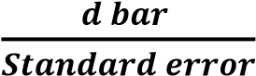

**Working Procedure:**

Define variables Before and After → Type, Numeric → Label → Memory capacity before training, memory capacity after training → Input data in data view→ Analyze → Compare mean → Pared sample t-test → Put before training in variable 1 → Put after training in variable 2→ Option, fix 95% → Continue → Ok

**SPSS OUTPUT:**

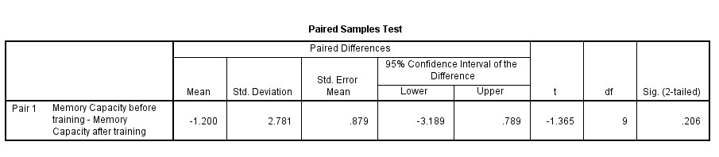

**Setting of Hypothesis:**

𝑯𝟎: The training was not effective

𝑯𝟏: The training was effective (one tailed test)

**Level of significance:**

α = 0.05 2p = 0.206 p = 0.103

**Decision:**

Since p = 0.103 > α = 0.05, we accept 𝑯𝟎 **Conclusion:**

Hence, we conclude that the training was not effective.

**Name: Sulav Adhikari**

**Roll Number: 23081003**

**Subject: Statistics II, Lab 3**

**Section: B**

**Q. No. 6:**

**Working Expression:**

**t =**

**Working Procedure:**

Define variables Before and After → Type, Numeric → Label → sale of laptop before advertisement, sale of laptop after advertisement →Input data in data view→ Analyze → Compare mean → Pared sample t-test → Put before training in variable 1 → Put after training in variable 2→ Option, fix 95% → Continue → Ok

**SPSS OUTPUT:**

|  |  |  |  |  |  |  |  |  |  |
| --- | --- | --- | --- | --- | --- | --- | --- | --- | --- |
| **Paired Samples Test** | | | | | | | | | |
|  | | | | | | | | | |
|  | | Paired Differences | | | | | t | df | Sig. (2-tailed) |
| Mean | Std. Deviation | Std. Error Mean | 95% Confidence Interval of the Difference | |
| Lower | Upper |
| Pair 1 | sale of laptop before advertisement - sale of laptop after advertisement | -4.125 | 1.553 | .549 | -5.423 | -2.827 | -7.514 | 7 | .000 |

**Setting of Hypothesis:**

𝑯𝟎: The training was not effective

𝑯𝟏: The training was effective (one tailed test)

**Level of significance:**

α = 0.05

**Decision:**

2p=0.206

p = 0.103

Since p = 0.103 > α = 0.05, we accept 𝑯𝟎

**Conclusion:**

Hence, we conclude that the training was not effective.